The following source ids have the same website structure.
Source ID | Source Title | url
77091799 | Demokratizatsiya | http://muse.jhu.edu/journal/674
78046499 | Mouvement Social | https://muse.jhu.edu/journal/423
78052599 | German Studies Review | https://muse.jhu.edu/journal/552
78061799 | Labour/ Le Travail | https://muse.jhu.edu/journal/537
78064199 | Great Plains Quarterly | http://muse.jhu.edu/journal/627
78096099 | Studies in Latin American Popular Culture | https://muse.jhu.edu/journal/506
78442399 | Journal of Negro Education | https://muse.jhu.edu/journal/794
79032299 | Common Knowledge | https://muse.jhu.edu/journal/32
79107499 | Hispania | https://muse.jhu.edu/journal/472
79334599 | Science-Fiction Studies | https://muse.jhu.edu/journal/780
79336999 | Journal of the Southwest | https://muse.jhu.edu/journal/530
79337199 | English Studies in Canada | https://muse.jhu.edu/journal/369
79337399 | Arthuriana | https://muse.jhu.edu/journal/397
79337899 | Oregon Historical Quarterly | https://muse.jhu.edu/journal/845
79338099 | World Literature Today | https://muse.jhu.edu/journal/842
79338599 | CEA Critic | https://muse.jhu.edu/journal/593
79338799 | Latin American Theatre Review | http://muse.jhu.edu/journal/519
79352599 | Bulletin of the Comediantes | https://muse.jhu.edu/journal/425
79352999 | Arion - Journal of Humanities and the Classics | https://muse.jhu.edu/journal/834
79361299 | American Journal of Philology | https://muse.jhu.edu/journal/6
79361399 | American Quarterly | https://muse.jhu.edu/journal/13
79361499 | Arethusa | https://muse.jhu.edu/journal/14
79361599 | Comparative Literature Studies | https://muse.jhu.edu/journal/33
79361699 | Eighteenth-Century Studies | https://muse.jhu.edu/journal/55
79361799 | ELH - English Literary History | https://muse.jhu.edu/journal/58
79361899 | Journal of the History of Philosophy | http://muse.jhu.edu/journal/76
79362099 | MLN - Modern Language Notes | https://muse.jhu.edu/journal/128
79362199 | New Literary History | https://muse.jhu.edu/journal/144
79362299 | Sewanee Review | https://muse.jhu.edu/journal/367
79362499 | SEL - Studies in English Literature | https://muse.jhu.edu/journal/178
79362699 | Lion and the Unicorn | https://muse.jhu.edu/journal/201
79362799 | Callaloo | https://muse.jhu.edu/journal/27
79362899 | American Jewish History | https://muse.jhu.edu/journal/4
79362999 | Philosophy and Literature | https://muse.jhu.edu/journal/158
79363099 | Theatre Journal | https://muse.jhu.edu/journal/196
79363199 | Henry James Review | https://muse.jhu.edu/journal/72
79363399 | Diacritics | https://muse.jhu.edu/journal/46
79363799 | Postmodern Culture | https://muse.jhu.edu/journal/160
79363899 | Journal of Early Christian Studies | https://muse.jhu.edu/journal/50
79363999 | Modernism - Modernity | https://muse.jhu.edu/journal/131
79364099 | Civil War History | https://muse.jhu.edu/journal/42
79365699 | Modern Language Review | https://muse.jhu.edu/journal/822
79365999 | Philosophy East and West | https://muse.jhu.edu/pub/5/journal/156
79366099 | Biography - An Interdisciplinary Quarterly | https://muse.jhu.edu/journal/25
79366199 | Asian Theatre Journal | https://muse.jhu.edu/journal/20
79366299 | American Literary Realism | https://muse.jhu.edu/journal/379
79366499 | Journal of Aesthetic Education | https://muse.jhu.edu/journal/235
79366599 | Journal of English and Germanic Philology | https://muse.jhu.edu/journal/450
79366699 | American Music | https://muse.jhu.edu/journal/448
79366799 | Journal of Film and Video | https://muse.jhu.edu/journal/382
79366899 | French Forum | https://muse.jhu.edu/journal/63
79366999 | Nineteenth-Century French Studies | https://muse.jhu.edu/pub/17/journal/137
79367099 | Studies in American Indian Literatures | https://muse.jhu.edu/journal/246
79367199 | Legacy | https://muse.jhu.edu/journal/115
79370899 | ESQ - Journal of the American Renaissance | https://muse.jhu.edu/journal/375
79380799 | Monumenta Nipponica | https://muse.jhu.edu/journal/308
79380999 | Dickens Quarterly | https://muse.jhu.edu/journal/654
79381199 | Esprit Createur | https://muse.jhu.edu/journal/333
79381299 | Film History: An International Journal | https://muse.jhu.edu/journal/285
79381999 | Journal of Biblical Literature | https://muse.jhu.edu/journal/513
79382899 | Notes | https://muse.jhu.edu/journal/145
79382999 | Catholic Historical Review | https://muse.jhu.edu/journal/28
79383099 | Classical World | https://muse.jhu.edu/journal/317
79383199 | Criticism | https://muse.jhu.edu/journal/40
79383299 | Cultural Critique | https://muse.jhu.edu/journal/41
79383799 | Style | http://muse.jhu.edu/journal/680
79383899 | Studies in the Novel | https://muse.jhu.edu/journal/395
79383999 | Studies in American Fiction | https://muse.jhu.edu/journal/478
79384399 | Journal of Feminist Studies in Religion | https://muse.jhu.edu/journal/294
79385099 | William and Mary Quarterly | https://muse.jhu.edu/journal/664
79385799 | Western American Literature | https://muse.jhu.edu/journal/418
79386199 | James Joyce Quarterly | https://muse.jhu.edu/journal/372
79386399 | Comparative Drama | https://muse.jhu.edu/journal/358
79386599 | Journal of the Early Republic | http://muse.jhu.edu/journal/295
79387099 | Scandinavian Studies | http://muse.jhu.edu/journal/526
79387199 | Comitatus | http://muse.jhu.edu/journal/546
79392099 | Soundings | https://muse.jhu.edu/journal/564
79392599 | Ploughshares | https://muse.jhu.edu/journal/542
79392899 | Southwestern Historical Quarterly | https://muse.jhu.edu/journal/340
79393299 | Journal of the Midwest Modern Language Association | http://muse.jhu.edu/journal/517
79393999 | Massachusetts Review | https://muse.jhu.edu/journal/660
79394699 | Virginia Quarterly Review | https://muse.jhu.edu/journal/647
79394899 | Ariel | https://muse.jhu.edu/journal/625
79396299 | New England Review-Middlebury Series | https://muse.jhu.edu/journal/541
79403599 | Sign Language Studies | https://muse.jhu.edu/journal/184
79403899 | Eire-Ireland | https://muse.jhu.edu/journal/244
79439199 | College Literature | https://muse.jhu.edu/pub/1/journal/215
79439699 | African American Review | https://muse.jhu.edu/journal/434
79440899 | Bach | https://muse.jhu.edu/journal/791
79441899 | Twentieth Century Literature | https://muse.jhu.edu/journal/652
79443399 | Tulsa Studies in Womens Literature | https://muse.jhu.edu/journal/373
79443699 | Slavonic and East European Review | https://muse.jhu.edu/journal/823
79443899 | Portuguese Studies | https://muse.jhu.edu/journal/821
79445499 | Chaucer Review | https://muse.jhu.edu/journal/38
79445599 | Philosophy and Rhetoric | http://muse.jhu.edu/journal/151
79447199 | Conradiana | https://muse.jhu.edu/journal/362
79447299 | Helios | https://muse.jhu.edu/journal/363
79447399 | Eighteenth Century | https://muse.jhu.edu/journal/364
79447499 | Early American Literature | https://muse.jhu.edu/journal/49
79447799 | Southern Cultures | https://muse.jhu.edu/journal/177
79447999 | Romance Notes | https://muse.jhu.edu/journal/588
79452499 | Milton Studies | https://muse.jhu.edu/journal/570
79453899 | Hispanic Review | https://muse.jhu.edu/pub/56/journal/289
79453999 | Journal of American Folklore | https://muse.jhu.edu/journal/87
79454099 | Narrative | https://muse.jhu.edu/journal/135
79454199 | New Centennial Review | https://muse.jhu.edu/journal/139
79454299 | Parergon | https://muse.jhu.edu/journal/309
79454899 | Partial Answers | https://muse.jhu.edu/journal/376
79455099 | Journal of the Society of Christian Ethics | https://muse.jhu.edu/journal/584
79460099 | Revista de Estudios Hispanicos | https://muse.jhu.edu/journal/563
79460699 | Studies in the Literary Imagination | http://muse.jhu.edu/issue/36598
79461599 | Kritika | https://muse.jhu.edu/journal/108
79461799 | Archives of Asian Art | https://muse.jhu.edu/journal/427
79475199 | Theatre History Studies | http://muse.jhu.edu/journal/577
79477799 | Black Music Research Journal | https://muse.jhu.edu/journal/469
79478799 | JNT-Journal of Narrative Theory | https://muse.jhu.edu/journal/262
79482599 | Studies in Eighteenth Century Culture | https://muse.jhu.edu/journal/378
79482699 | Studies in the Age of Chaucer | https://muse.jhu.edu/journal/416
79483599 | Wallace Stevens Journal | https://muse.jhu.edu/journal/528
79484699 | Eighteenth-Century Fiction | https://muse.jhu.edu/journal/324
79487899 | Huntington Library Quarterly | http://muse.jhu.edu/journal/677
79495399 | Logos (United States) | https://muse.jhu.edu/journal/120
79529599 | Scottish Literary Review | http://muse.jhu.edu/journal/614
79689599 | Journal of Burma Studies | https://muse.jhu.edu/journal/529
79790399 | American Book Review | https://muse.jhu.edu/journal/467
80014499 | Aleph | https://muse.jhu.edu/journal/283
80015399 | Victorian Periodicals Review | https://muse.jhu.edu/journal/304
80016799 | Journal of Korean Studies | https://muse.jhu.edu/journal/515
80017899 | Spiritus | https://muse.jhu.edu/journal/176
259416799 | Contagion: Journal of Violence, Mimesis, and Culture | https://muse.jhu.edu/journal/385
259416899 | Fourth Genre: Explorations in Nonfiction | https://muse.jhu.edu/journal/217
259416999 | French Colonial History | https://muse.jhu.edu/journal/218
259417199 | Northeast African Studies | https://muse.jhu.edu/journal/136
259417399 | Rhetoric and Public Affairs | http://muse.jhu.edu/journal/171
259417799 | Journal of Modern Periodical Studies | https://muse.jhu.edu/journal/473
259417899 | Journal of Nietzsche Studies | https://muse.jhu.edu/journal/142
259417999 | Journal of Speculative Philosophy | https://muse.jhu.edu/pub/2/journal/104
259418099 | Pennsylvania History | https://muse.jhu.edu/journal/476
259418199 | SHAW | https://muse.jhu.edu/journal/180
273541999 | AJS Review | https://muse.jhu.edu/journal/844
273545499 | Journal of Song-Yuan Studies | https://muse.jhu.edu/pub/1/journal/424
278971499 | Toronto Journal of Theology | https://muse.jhu.edu/journal/527
281856199 | Journal of Shi'a Islamic Studies | http://muse.jhu.edu/journal/582
290365699 | Philosophical Topics | http://muse.jhu.edu/journal/610
290367899 | Jewish Quarterly Review | https://muse.jhu.edu/journal/292
290367999 | Film and History | https://muse.jhu.edu/journal/242
290368499 | Journal of Ecumenical Studies | https://muse.jhu.edu/journal/668
290368999 | Hebrew Studies | https://muse.jhu.edu/journal/512
299246799 | Franciscan Studies | https://muse.jhu.edu/journal/457
299307899 | Eriu | https://muse.jhu.edu/journal/809
318818599 | Ethics and the Environment | https://muse.jhu.edu/journal/57
326903599 | Victorians | https://muse.jhu.edu/journal/718
329987699 | Indiana Journal of Global Legal Studies | https://muse.jhu.edu/journal/236
339493499 | History and Memory | https://muse.jhu.edu/journal/71
339493599 | Journal of Modern Literature | https://muse.jhu.edu/journal/97
339493699 | Nashim | https://muse.jhu.edu/journal/243
339494399 | T'ang Studies | https://muse.jhu.edu/journal/778
342664699 | Austrian Studies | https://muse.jhu.edu/journal/819
637565126 | Magic, Ritual, and Witchcraft | http://muse.jhu.edu/journal/387
667224501 | Journal of Global South Studies | https://muse.jhu.edu/journal/715
756590128 | Israel Studies | http://muse.jhu.edu/journal/85
808068913 | Eugene O'Neill Review | https://muse.jhu.edu/journal/551
808068914 | Interdisciplinary Literary Studies | https://muse.jhu.edu/journal/555
808068917 | Journal of Africana Religions | http://muse.jhu.edu/journal/598
808068920 | Mark Twain Annual | https://muse.jhu.edu/journal/603
808068921 | Pacific Coast Philology | https://muse.jhu.edu/journal/635
808068922 | Reception: Texts, Readers, Audiences, History | https://muse.jhu.edu/journal/602
808068923 | Steinbeck Review | https://muse.jhu.edu/journal/377
808068945 | Journal of Southeast Asian Economies | https://muse.jhu.edu/journal/347
908891701 | Jewish Social Studies | http://muse.jhu.edu/journal/105
911497006 | Journal of Austrian studies | http://muse.jhu.edu/journal/599
923636370 | Revista Hispanica Moderna | https://muse.jhu.edu/journal/426
930832599 | African Conflict and Peacebuilding Review | https://muse.jhu.edu/journal/509
932284399 | Information and Culture | https://muse.jhu.edu/journal/111
77248999 | Korean Studies | https://muse.jhu.edu/journal/109
943736843 | Children's Literature | https://muse.jhu.edu/issue/47810
78051099 | Feminist Studies | https://muse.jhu.edu/pub/434/journal/846
79164299 | African Economic History | https://muse.jhu.edu/pub/19/journal/482
79352899 | Studies in Romanticism | https://muse.jhu.edu/pub/1/journal/754
79361999 | MFS - Modern Fiction Studies | https://muse.jhu.edu/pub/1/journal/125
79362599 | Reviews in American History | https://muse.jhu.edu/pub/1/journal/168
79363299 | Literature and Medicine | https://muse.jhu.edu/pub/1/journal/118
79363499 | Journal of Modern Greek Studies | https://muse.jhu.edu/pub/1/journal/126
79363599 | Late Imperial China | https://muse.jhu.edu/pub/1/journal/114
79363699 | Journal of Women's History | https://muse.jhu.edu/pub/1/journal/100
79368599 | Sub-Stance | https://muse.jhu.edu/pub/1/journal/189
79384899 | Journal of Southern History | https://muse.jhu.edu/journal/685
79393599 | Journal of Mediterranean Studies | https://muse.jhu.edu/pub/303/journal/728
79395099 | Hesperia | https://muse.jhu.edu/pub/55/journal/288
79396099 | Classical Journal | https://muse.jhu.edu/pub/1/journal/317
79439799 | French Review | https://muse.jhu.edu/pub/1/journal/777
79447899 | Hispanofila | https://muse.jhu.edu/pub/210/journal/586
79448399 | Fontes Artis Musicae | https://muse.jhu.edu/pub/287/journal/688
79449999 | New York History | https://muse.jhu.edu/pub/255/journal/745
79454699 | Victorian Poetry | https://muse.jhu.edu/pub/1/journal/204
79465499 | Confluencia | https://muse.jhu.edu/pub/442/journal/667
79480699 | Canadian Review of Comparative Literature | https://muse.jhu.edu/pub/260/journal/638
80009499 | Yale Review | https://muse.jhu.edu/pub/1/journal/789
259417499 | American Periodicals | https://muse.jhu.edu/pub/30/journal/263
298819999 | Journal of Sport History | https://muse.jhu.edu/pub/34/journal/474
301971199 | South Central Review | https://muse.jhu.edu/pub/1/journal/245
318820599 | Journal of Middle East Women's Studies | https://muse.jhu.edu/pub/4/journal/329
348855999 | Journal of Korean Religions | https://muse.jhu.edu/pub/5/journal/557
634575217 | Journal of the Malaysian Branch of the Royal Asiatic Society | https://muse.jhu.edu/pub/126/journal/480
637565127 | Change Over Time | https://muse.jhu.edu/pub/56/journal/545
667031502 | Yearbook of Comparative Literature | https://muse.jhu.edu/pub/50/journal/447
808068924 | Studies in American Humor | https://muse.jhu.edu/pub/2/journal/656
915617150 | Black Camera | https://muse.jhu.edu/pub/3/journal/468
921632029 | Philosophy of Music Education Review | https://muse.jhu.edu/pub/3/journal/228
922183238 | Journal of the Ottoman and Turkish Studies Association | https://muse.jhu.edu/pub/3/journal/761
932533402 | Feminist German Studies | https://muse.jhu.edu/pub/17/journal/403
948614234 | ASAP Journal | https://muse.jhu.edu/pub/1/journal/684
948614239 | Digital Philology: Journal of Medieval Cultures | https://muse.jhu.edu/pub/1/journal/550
948614245 | Journal of Jewish Identities | https://muse.jhu.edu/pub/1/journal/463

Please download the current/Latest issue only

Kindly note Inside of AWS under Elsevier authorized environment no need logins to access to pdfs.

Outside of AWS needs to login to download like below.
Use below creditional if login only outside of AWS.

UserName | Password
scopus1 | 1779290


First go to be website using base url so you will direct to select source website. So the issue archive will appear like this.
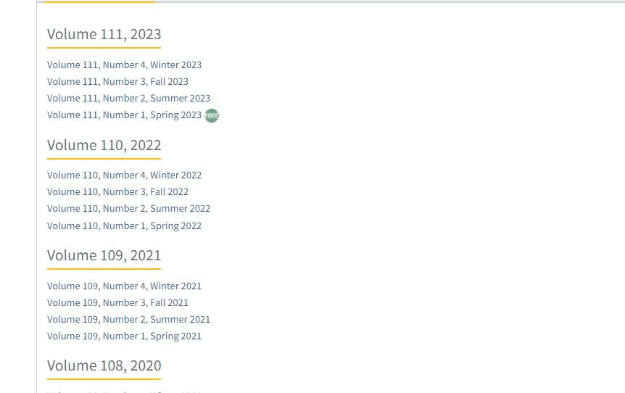
Select the Current issue from here.

- Select the Current/Latest issue from the issue list.
- After selecting the issue content will appear here.

- All required articles will be listed here.

Page range

title
Doi number

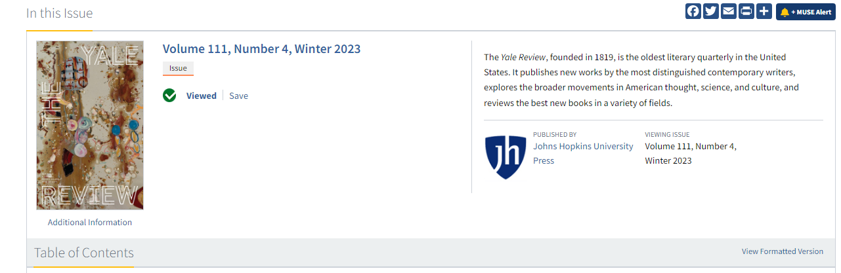

Volume , issue, part number , month and Year

Please note the following keywords to identify volume issue numbers in website.
Tom | Volume number
Numero | Issue number
Heitz | Volume number
Jahrang | Volume number

Click the article name to open the article information page to download the PDF.

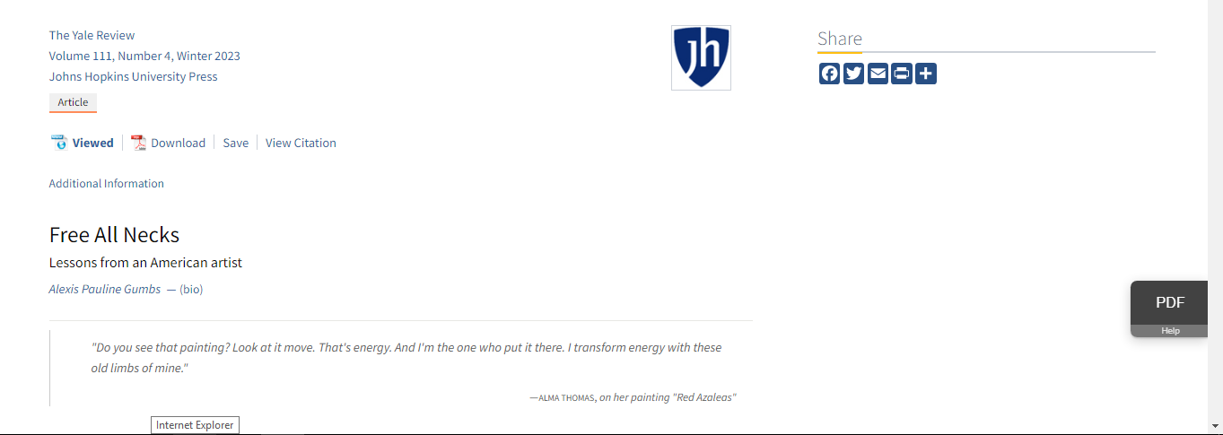

Apply following step to download the PDF.
Then click here to download the pdf
- First click article title and then display download page.

